|  |  |
| --- | --- |
| **General Requirements** | |
| Functional   * The tests will collect a score based against a marking grid based on performance of the patient * The score should be affected by the time limits per game beforehand * All activity/movement should be logged in the database * Instructions from the SDSA manual must be shown beforehand | Non-Functional   * The score will be altered by time taken, wrong answers and will make use of the algorithm provided (fig 5) * The time limit will not shut down the games however will affect score if exceeded – should not affect gameplay * Instructions can be repeated once more if required |

|  |  |
| --- | --- |
| **Game 1 – Dot Matrix** | |
| Functional   * A grid of dot clusters will be displayed * Dot clusters should be able to be clicked on * The user should be able to navigate between quadrants using buttons * The game will be time limited by 15 minutes * The game will be scored via time taken, number of errors in dots missed and the number of false positives of groups cancelled in error | Non-Functional   * Clusters are randomised with 3-5 different dots * The game screen should be split into quadrants * When clicked on, dot clusters must be highlighted |

|  |  |
| --- | --- |
| **Game 2 – Road Sign Recognition** | |
| Functional   * A selection of different road situations are displayed on screen * Users will be able to pair sign with situation * There are more signs than situations available for user choice * The user will drag and drop the sign onto the situation image * The game will be time limited by 3 minutes * It will be scored with one point for each matched with a max of 12 points | Non-Functional   * Road signs will be shown like figure 1 or figure 2 * User can review their answers before submitting |

|  |  |
| --- | --- |
| **Game 3 and 4 – Square Matrices Directions & Square Matrices Compass** | |
| Functional   * The user should be able to assign a card to a space on the grid * The user will drag and drop the scenario picture into the grid spaces * This will continue until all spaces on the grid are filled * Each game will be limited to 5 minutes * Square Matrices Directions are scored 1 point for each correctly positions car and lorry, with a max of 32 * Compass game is scored for each vehicle correctly placed with a max of 32 | Non-Functional   * The grid is displayed in a 4x4 grid as per figure 3, with surrounding arrows and compass directions * The cards will be randomised and will also feature a “no fit” area |

|  |  |
| --- | --- |
| **Game 5 – Trail Making Test** | |
| Functional   * A board of circles is displayed with numbers from 1-25 * The user must draw a line between the circles connecting in ascending order | Non-Functional   * Numbers in circles are randomised * Circles must have sufficient spacing to draw lines between - figure 4 |

|  |  |
| --- | --- |
| **Overall Games** | |
| Functional   * After each game, user should be able to submit answers * Each game will be time limited and should be in order of Dot Matrix, Square Matrices, * Feedback should be provided * Images used will be royalty free * Score should be saved to a database along with patient details | Non-Functional   * Answers should be stored individually based on the game * Time limits will be set as per the SDSA manual * The feedback will only be presented after the test has concluded * Images should conform to the GNU General Public License (GPL) |

|  |  |
| --- | --- |
| **Login** | |
| Functional   * The clinician should have a screen where patient data and country preference is added before test commences | Non-Functional   * A screen will show when the device is in test mode |



Figure 1



Figure 2

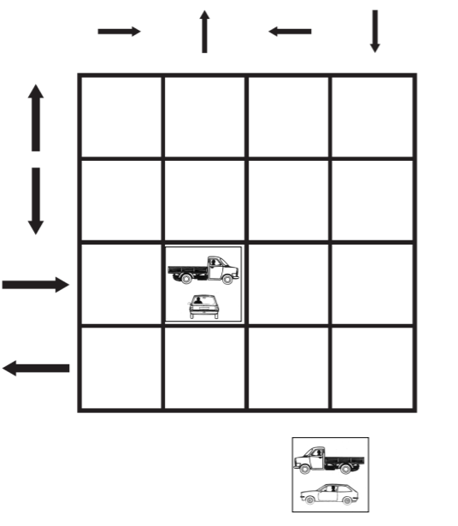

Figure 3

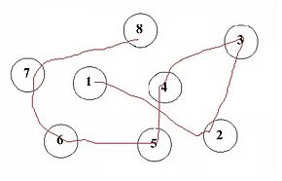

Figure 4

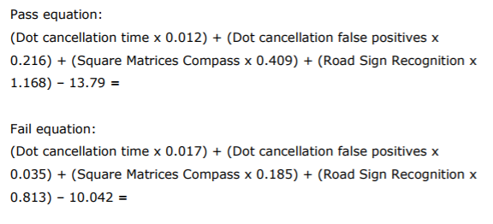

Figure 5